**Wood Panel Wallpaper in Nude**

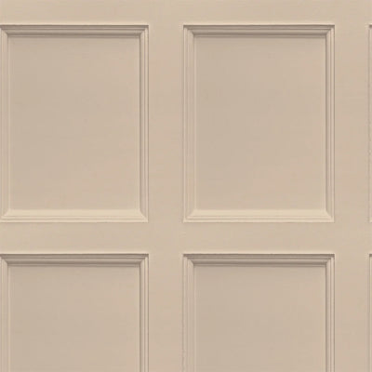Wood panel wallpaper in nude offers a minimalist and elegant aesthetic, perfect for creating a warm and inviting atmosphere. The soft nude tones bring a sense of natural serenity, complementing the timeless texture of vertical wood panels. With subtle grain details and gentle shading, this wallpaper design exudes understated sophistication, blending seamlessly with both modern and classic decor styles. Ideal for living rooms, bedrooms, or study areas, it adds depth and character to walls while maintaining a neutral and versatile backdrop, making it a refined choice for any interior space.